Report

Final project Matlab

Written by: Nguyen Quoc Huy – e1601121

# Abtract

This is the report of Final project Matlab of Basics of Mathematical Software class: “Finding out the shortest path between two points” application. The main idea is based on the Dijkstra's algorithm – a famous algorithm for finding the shortest paths between nodes in a graph. Much of the knowledge I used in the project is from <https://www.mathworks.com/>

# Introduction

This report is written by:

-Nguyen Quoc Huy e1600121

Instructor: Mr. Ojanen Jussi, teacher of Vamk. Email: [jussi.ojanen@vamk.fi](mailto:jussi.ojanen@vamk.fi)

The aim of the project is to create an application finding out the shortest path between two selected points on a matlab environment.

All the code and materials are attached with the report, these include: a matlab code file, a picture PNG file, a txt file. You should put them into the same directory folder and change the matlab current folder.

Requires matlab version 2016 or newer because some functions may not be available in previous versions.

# Description

I will describe each step I have studied and completed this project. And at the same time I will also explain the usage of the function that I used

Step 1:

I went to Google map and started cropping a map with an area of 1000x1000 square meters, namely the Palosaarentie area of Vaasa.

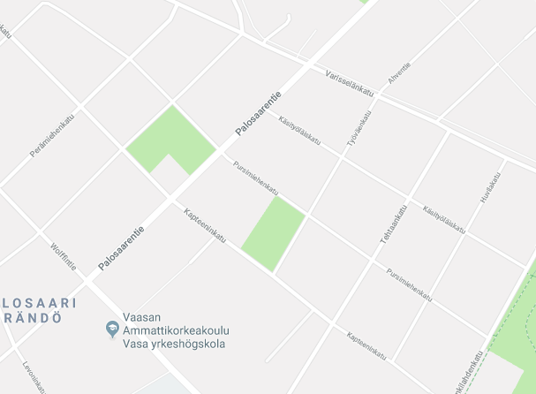

Then, I displayed it in a figure

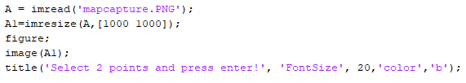

The function imresize returns image that is scale the size of what we define, here is 1000x1000

The function title writes the title for the figure

Step 2:

I used function:



This function returns the coordinates of the selected points which is chosen in the figure by using mouse. I want to find out all the coordinate of all the special points all the image:

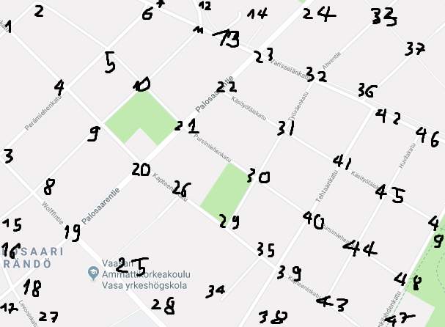

And this is the result:

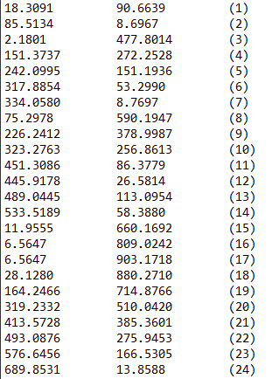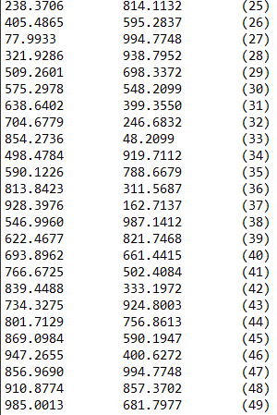

I also included the txt file of this data in the report, you can check it if you want

To draw the nodes map, we need to define the argument of function:

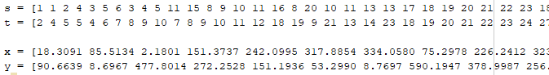

We have 49 points. The array s stands for start nodes, and t stands for end nodes. For example, you can see node 1 linked to node 2 and node 4 (on the before map) so that s[1] and s[2] are 1, t[1] is 2 and t[2] is 4. s[n] would be linked to t[n]. The arrays x and y stand for all coordinates of 49 points (I have to define them by hand, it took a lot of time)

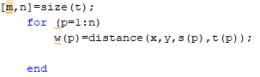  
Then, I used size function to find out the number of links of 49 nodes, here is the size of array t or s. I used for loop to define array w. The array w stands for the weight, which means the difficulty of moving between nodes. In this situation, w represents the distance between 2 nodes, and be called by the function distance:



Step 3:

My ideal is that you will select 2 points on the map, the program will find the 2 nearest nodes with 2 that selected points, and then find the shortest way. So basically, I have to used for loop function to find out which nodes is nearest with the selected points:

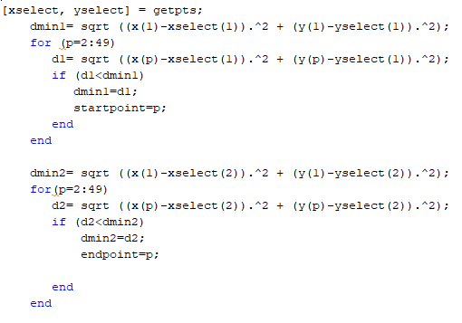

For a loop that runs 49 times, find the distance from the selected point to all nodes, which one is smallest we select that nodes to be the startpoint (for the first point) and the endpoint(for the second point)

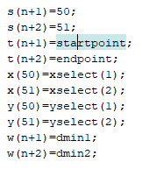

Insert 2 new point as 2 new nodes to array s, t, x, y, w. They are the 50th and 51th nodes.

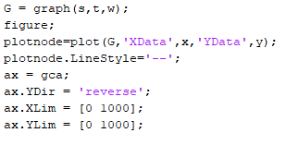

Plot the nodes graph.

Here I have to reverse the y-axes of the figure because I got some problem and the y-axes of this figure is opposite with the figure in step 1.

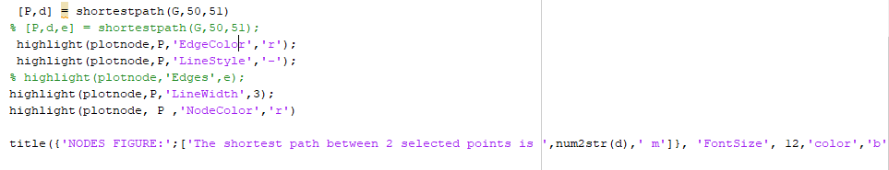

Finally, we call the shortestpath function. P stands for the nodes which is the shortest way, and d is the total distance.

4 functions highlight are used to highlight the shortest path found.

And then the title displays the shortest distance.

This is the example

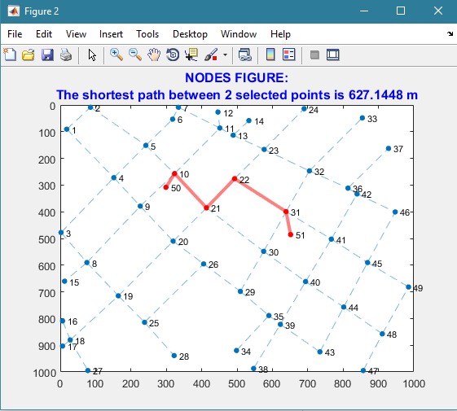

Step 4:

Now I want to display the shortest path on the map figure of the image (step 1). So that why I have to define 4 new s,t,x,y arrays for the new graph:

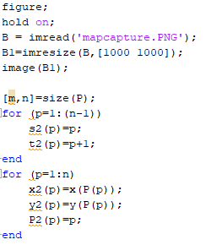

Now, we have found all the nodes of the shortest path, and they are stored in arrays P. Used the size function to detect how many nodes on the shortest path. Used for loop function to define the new s2, t2, x2, y2 arrays.

P2 stands for the array P in the new graph.

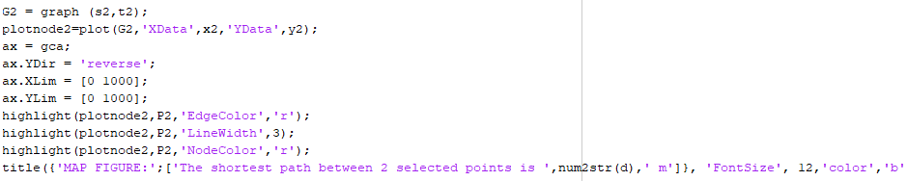

And finally, I plot the new figure with s2, t2, x2 and y2. I got the same problem with the y-axes so I have to use the reverse function.

4 functions highlight are used to highlight the shortest path found.

And then the title displays the shortest distance.

This is the example:

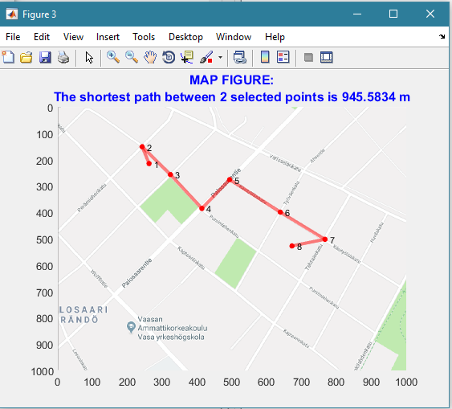

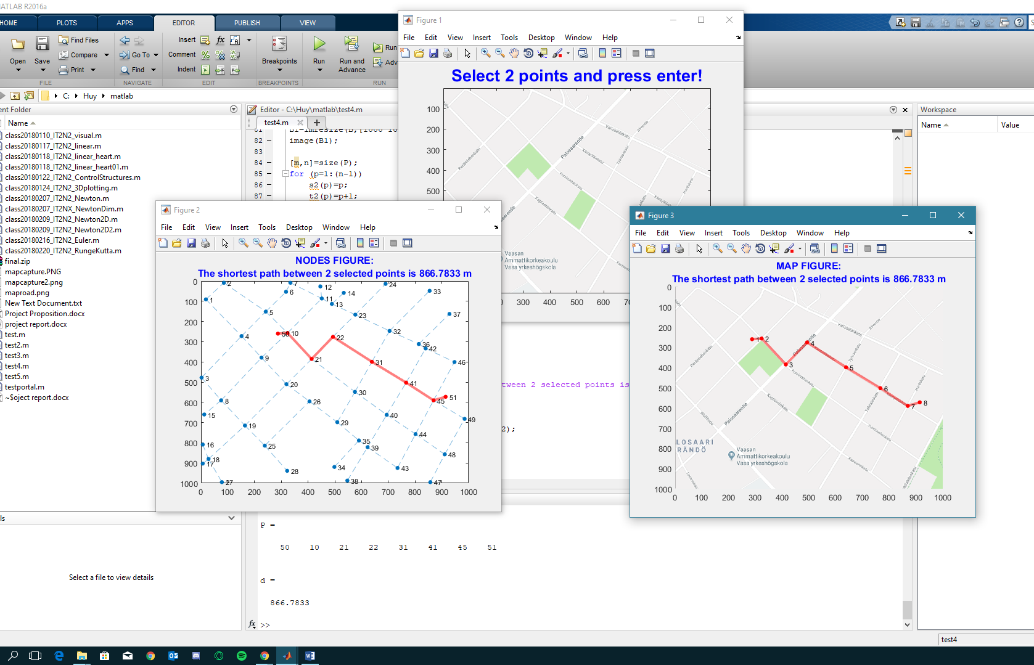

# Summary

In this report, I show step-by-step how can I work on the project, and also describe in detail the usage of all the function and codes.

Actually, I was going to use Dijkstra algorithm for this project, but in the process of finding out, I realized that matlab already has a shortestpath function to find the shortest way that its usage is based on Dijkstra algorithm. So I decided to use that function for convenience.

Reference source:

<https://se.mathworks.com/help/matlab/ref/graph.shortestpath.html>

<https://en.wikipedia.org/wiki/Dijkstra%27s_algorithm>

<https://se.mathworks.com/help/matlab/ref/graph.plot.html>

<https://www.google.com/maps>